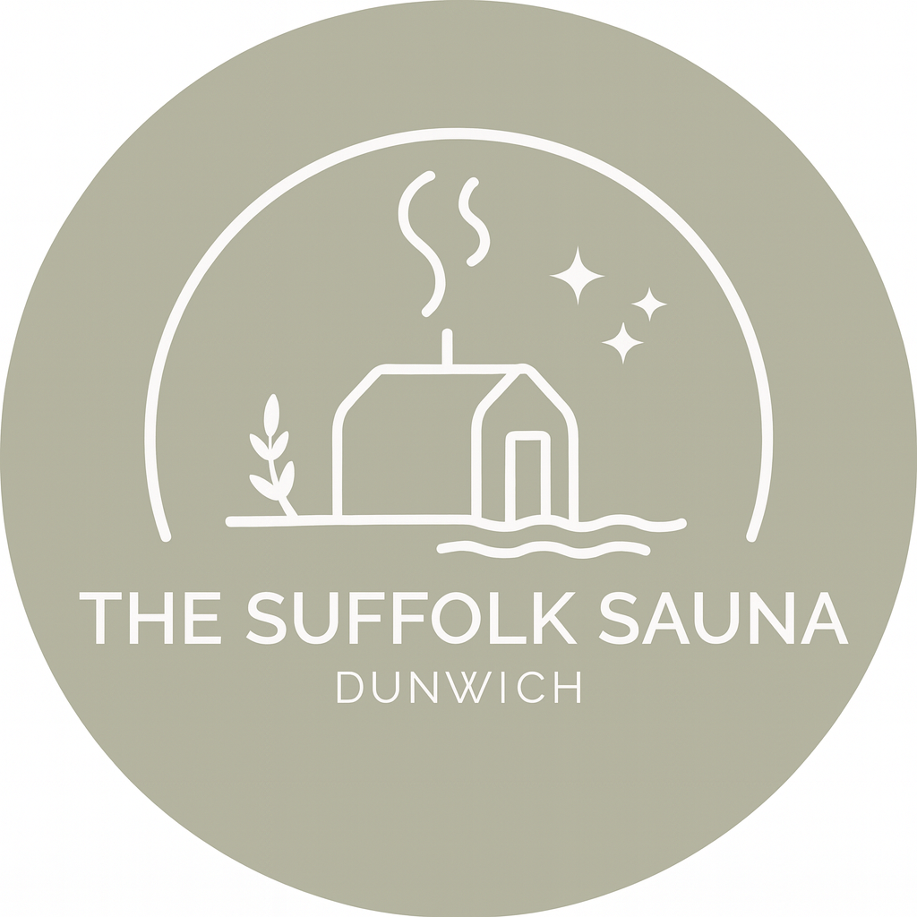

THE SUFFOLK SAUNA – UNDER-16 CONSENT & WAIVER FORM

Parent/Guardian Declaration

No under-7s are permitted in the sauna.
Children aged 7–16 may only use the sauna during private hire sessions as long as an adult family member/guardian is present at ALL TIMES during the hire and use of the sauna.
I/We …………………………………………………………(full name) are the Parent/Guardian/Adult Family Member (please delete accordingly) of ……………………………………………………. (minor’s full name) and sign to accept that we take full responsibility for the above-named minor during the Sauna hire use.
I/We have read and understood The Suffolk Sauna Terms & Conditions and give permission for them to participate.

Signature: _____________________________
Print Name: _____________________________
Date: ___________________

Please email completed form to hello@thesuffolksauna.uk
Thank you for your assistance and enjoy your sauna!

